Circuit Analysis(Lab3)
Experiment3:Introduction to Multimeter and Basic Series Circuit Implementation

Name: Noor-ul-Ain
Registration No: 2025-CE-83
Date: 27th March, 2026. Grade and Signature:
CLO2  CLO3 | Use with identification the circuit components, breadboards, multimeters, power supplies, signal generators, and oscilloscopes.  Make measurements in their own constructed electric circuits.
Psychomotor/Affective | Level1  (1) | Level2  (2-3) | Level3  (4-5) | Level4  (6-7)
ReportMarks(3) |  |  | Total marks(10)

Objectives: To get understanding of how to use a multimeter and make measurements in your own constructed series circuits.
Equipment required:
Power Supply, Breadboard ,Connecting wires, Resistances, Multimeter.

Lab Tasks:

  - Measure Current between R1and R2,and VoltageacrossR1,R2.
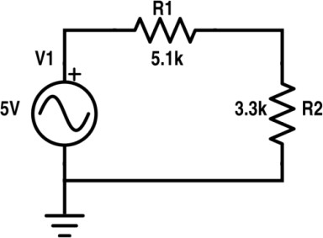

Practical Values:

R1 Voltage | R2 Voltage | Current
3.04 | 1.96 | 0.60

TheoreticalValues:

R1 Voltage | R2 Voltage | Current
3.04 | 1.96 | 0.60

  - Measure Current at node 2 and 3 and Voltage across R1,R2, R3.

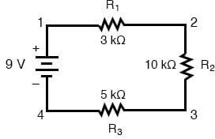

PracticalValues:

R1 Voltage | R2 Voltage | R3 Voltage | Currentatnode2 | Currentatnode3
1.50 | 5.00 | 2.50 | 0.50 | 0.50

TheoreticalValues:

R1 Voltage | R2Voltage | R3 Voltage | Currentatnode2 | Currentatnode3
1.50 | 5.00 | 2.50 | 0.50 | 0.50

Post Lab Questions:
- Define energy.
Energy is the ability to do work or produce change.
Its SI unit is joule (J).
]
- Define power.

Power is the rate at which energy is used or work is done.
P=W /t
Where:
- PPP = power
- WWW = work (energy)
- ttt = time
SI unit: Watt (W)

- What is charge?
Electric charge is a fundamental property of matter responsible for electrical effects and forces.
- Two types: positive and negative
- SI unit: Coulomb (C)
- Represented by Q
- Flow of charge forms electric current.

- What is circuit?
An electric circuit is a closed conducting path through which electric current flows.

Main parts of a circuit:
- Power source (battery/supply)
- Conducting wires
- Load (resistor, bulb, etc.)

- What is the role of a resistor in the series circuit?
- Limits current flow.
- Protects components from excessive current.
- Causes voltage drop.
- Controls power distribution.
- Converts electrical energy into heat.
- Same current flows through all resistors.
- Total resistance increases when resistors are added in series.

- What is the voltage divider rule?
The voltage divider rule states that:
In a series circuit, the total voltage divides across resistors proportional to their resistance.
Vi=Vtotal Ri /Rtotal
- Larger resistance → larger voltage drop.
- Used to obtain required output voltage

- What are the features of the series circuit?
- Only one path for current.
- Same current flows through all components.
- Total resistance is sum of resistances:
RT=R1+R2+R3
- Voltage divides across components.
- If one component fails → entire circuit stops.
- Simple and easy to analyze.

- Differentiate between the internal circuit of voltmeter and ammeter.
Instrument | Internal Resistance | Connection | Purpose
Voltmeter | Very high resistance | Parallel | Measures voltage
Ammeter | Very low resistance | Series | Measures current

- In which combination we connect DMM to measure current and voltages.
(DMM = Digital Multimeter)
- To measure voltage → Parallel connection
- To measure current → Series connection

14.

